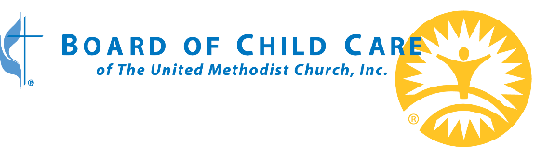
Sample Bulletin Text
Board of Child Care (BCC) is an independent children and family focused charity. Their programs now span across the Mid-Atlantic, but they started as three orphanages back at the turn of the 19th century. The Christmas Offering for the children served by BCC dates to 1954, when coin holders that held 10 dimes each were handed out in United Methodist Churches with the goal of teaching children to help give back to children who were less fortunate.
BCC has certainly grown since 1954, but the Christmas Offering is still teaching the same valuable life lesson. The proceeds from the Christmas Offering are first used to fund the holiday celebrations and Christmas presents for those living at BCC. BCC’s spiritual life team leads programs for the holidays and ensures that the message of God’s unconditional love is offered to all. Personalized gifts from each child’s wish list help convey in a tangible way God’s love and grace. After the needs of the holidays are met, donations will be directed to where they are needed most throughout BCC's programs.
Strive for the things that bring peace and the things that build each other up. Romans 14:19
Please consider donating to help show God’s love to a youth and his or her family in need. You can also donate online from your computer or phone at boardofchildcare.org/christmas/
For more information about BCC’s programs which provide educational services, mental health services and therapeutic residential services across the mid-Atlantic, please visit our website: boardofchildcare.org/programs.

Church administrators:
Looking for logos or other sample text? Visit boardofchildcare.org/christmas

